Dear patients,
Following the direction of the province on May 11th, Ontario is immediately pausing administration of the first dose of the AZ vaccine.
This email aims to provide an update and help you understand what we know and what is still to be determined.
- All the approved vaccines in Canada are similarly effective at preventing severe illness from COVID-19. This includes preventing hospitalizations and death.
- The AstraZeneca vaccine has been associated with a syndrome involving reduced platelets and unusual blood clots. This syndrome is now most commonly called VITT (Vaccine-Induced Thrombotic Thombocypenia). Based on Ontario data to date, we now think it happens after around 1 in every 60,000 injections, and the overall risk estimate changes depending on the data source. You can read more about VITT here.
- This syndrome called VITT is not seen with the mRNA vaccines (Pfizer or Moderna).
- We have a great deal of mRNA vaccine in Ontario now and much more coming. There should be enough mRNA vaccine to get it to everybody 18 years of age and older in the ‘hot spots’ over the next 10 days. It is hoped that by May 24, 2021, everyone 18 years of age and older will be eligible to get an appointment.
- If you are eligible but not sure whether you should be vaccinated, contact your primary care provider - let’s talk about it.
We know that people who have received the AstraZeneca vaccine have many questions. We answer these based on what we know today. As we find out more, we will continue to update you.
- If you received the AstraZeneca vaccine more than 28 days ago, that is great as you are well on your way to protection. Your next dose will likely be Pfizer or Moderna though we are still waiting details on that. When we know more about this, we will pass those details on to you.
- If you received the AstraZeneca vaccine less than 28 days ago, then you need to know what to watch for and how to manage any anxiety this news may bring.
  - What to watch for: After a vaccination, it is normal to feel tired, achy, feverish, or have soreness at injection site. Those are not signs of VITT. VITT is rare and has better treatment & outcome when identified early. Symptoms of VITT may occur 4-28 days following AstraZeneca and are listed in the infographic below:
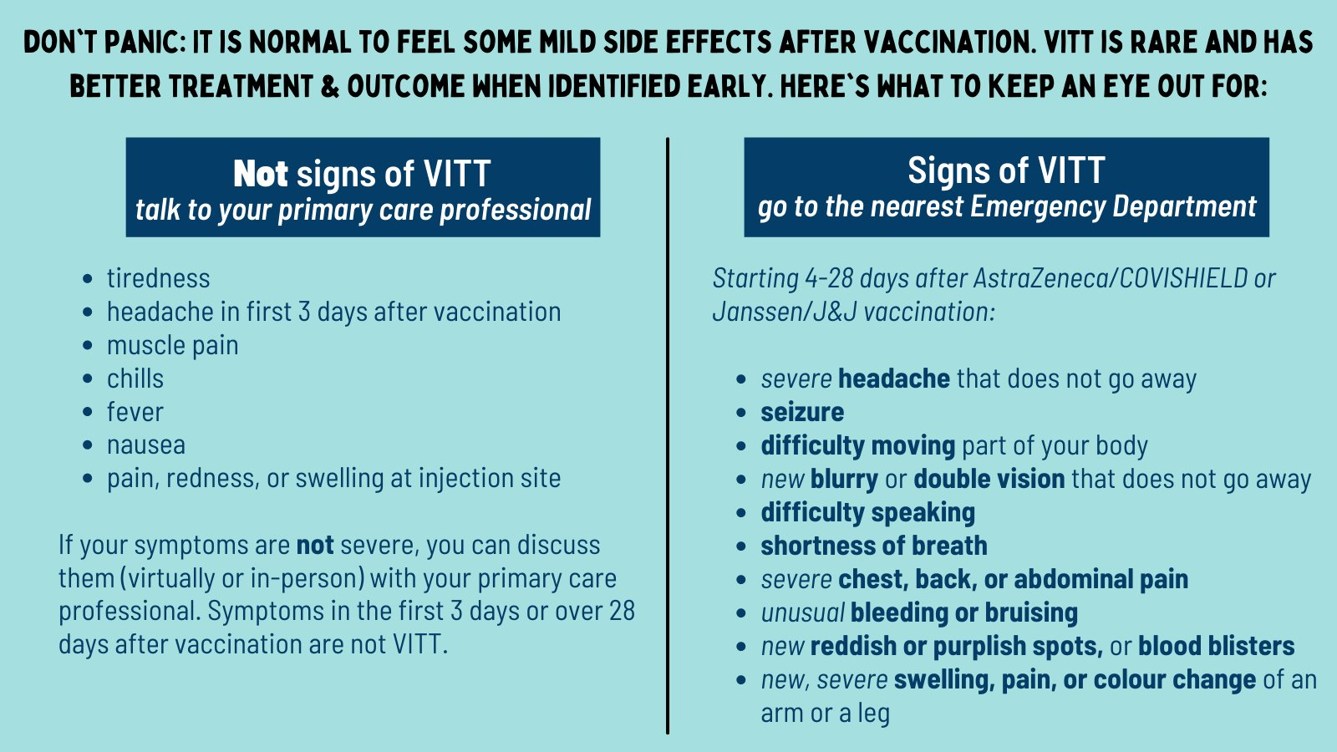
These symptoms can also be a sign of other serious conditions and should be assessed in an emergency department. If your symptoms are not severe, you can discuss them (virtually or in-person) with your primary care professional.
  - How to manage anxiety while you wait to get to 28 days: 1) focus on the benefit you have obtained as your body uses this time to build immunity for you and those around you; 2) try online services that may include support groups, mindfulness, or therapy like Wellness Together or MindBeacon 3) talk to someone through the ConnexOntario Helpline (1-866-531-2600) or 211 Ontario (2-1-1) or 4) reach out to us to discuss and for support.
Please remember serious side effects are very rare.
As a team, we continue to be available to help and support you.
Warmly,
Your team at ________ Practice

