CMHA Mental Health Tips Amid COVID-19 Concerns
Digital package for social media

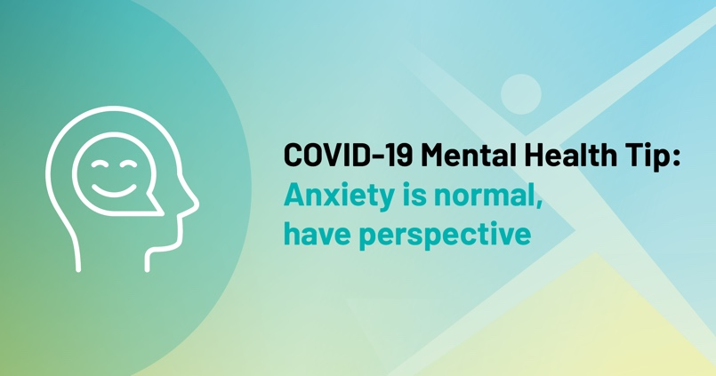

PURPOSE:
This digital package was created to support branches’ communication efforts in response to COVID-19. You can use the following resources to share mental health tips amid COVID-19 concerns.

DIGITAL MATERIALS IN THIS PACKAGE:
- Sample web story
- Social media posts
- Social media graphics

SUGGESTED TIMELINE OF ACTIVITIES:

Timeline | Channel | Activities
ASAP | Website | - Post web story and link to web story
 | Twitter | - Share social media posts
 | Facebook | - Share social media posts
 | Instagram | - Share social media posts

SAMPLE WEB STORY:
Tips to manage mental health through COVID-19 pandemic

In the wake of COVID-19, Canadians are facing a new reality of social distancing, self-quarantining and isolation in order to protect public health and safety. These new circumstances may lead individuals with mental health concerns into heightened symptoms of anxiety and depression.

In what may be a difficult time for many, the Canadian Mental Health Association (CMHA) is offering some basic tips to help people remain calm and balanced as this public health situation unfolds.

- Considering the level of attention and seriousness being paid to the COVID-19 pandemic, it’s normal to feel anxious. Try not to avoid, ignore or suppress anxious thoughts. Instead, be aware of your anxiety and accept that you’re feeling anxious in this situation. Try to keep things in perspective; notice and challenge your thoughts that may be extreme or unhelpful.

- Self-care is critically important at this time, as worries can be made worse if we aren’t taking care of ourselves. Lean on social supports, try to get enough sleep, eat healthy, exercise and engage in enjoyable activities. Do the things you would typically do to support your health, and be sure to use caution and follow health and safety guidelines while doing them.

- Seek information from reliable news sources only. Limit checking in on the latest news to short, defined periods, and refrain from setting related push notifications on your device. Appropriate information consumption may be calming and can lessen the sense of danger.

- Take the recommended precautions as outlined by Health Canada and other credible health agencies. Remain focused on the factors within your control, such as washing hands, covering your mouth during coughs and sneezes, avoiding non-essential travel, etc.

- If you’re noticing that your symptoms of anxiety (in association with COVID-19 or otherwise) are causing you significant distress or are interfering with your ability to function normally, reach out for formal mental health supports from a recognized agency, such as CMHA.

CMHA Ontario and branches around the province provide programs and services to support your mental wellness, such as BounceBack, walk-in counselling, information on stress management, and much more. Learn more and find a local branch at ontario.cmha.ca.

SAMPLE SOCIAL MEDIA POSTS:
Facebook:

- Keep things in perspective. It’s normal to feel anxious considering the level of attention being paid to #COVID19. Notice and challenge your thoughts that may be extreme or unhelpful. Visit our website for additional #mentalhealth tips: <insert link to web story> <insert shareable graphic>

- Do things to support your #mentalhealth. Self-care is very important as worries can be made worse if we don’t do things to take care of ourselves during times of uncertainty. Visit our website for additional #mentalhealth tips: <insert link to web story> <insert shareable graphic> #COVID19

- Seek information from reliable news sources. Appropriate information consumption may be calming and can lessen the sense of danger during times of uncertainty. Visit our website for additional #mentalhealth tips: <insert link to web story> <insert shareable graphic> #COVID19

- Focus on factors within your control. Washing your hands and covering your mouth during coughs are a few of the recommended precautions from credible health agencies. Visit our website for additional #mentalhealth tips: <insert link to web story> <insert shareable graphic> #COVID19

- Contact your local CMHA Ontario branch. We provide programs and services to support your #mentalhealth even during times of uncertainty. Visit our website for additional #mentalhealth tips and our contact details: <insert link to web story> <insert shareable graphic> #COVID19

Twitter:
- Keep things in perspective. It’s normal to feel anxious considering the level of attention being paid to #COVID19. Notice and challenge your thoughts that may be extreme or unhelpful. Visit our website for additional #mentalhealth tips: <insert link to web story> <insert shareable graphic>

- Do things to support your #mentalhealth. Self-care is very important as worries can be made worse if we don’t do things to take care of ourselves during times of uncertainty. Visit our website for additional #mentalhealth tips: <insert link to web story> <insert shareable graphic> #COVID19

- Seek information from reliable news sources. Appropriate information consumption may be calming and can lessen the sense of danger during times of uncertainty. Visit our website for additional #mentalhealth tips: <insert link to web story> <insert shareable graphic> #COVID19

- Focus on factors within your control. Washing your hands and covering your mouth during coughs are a few of the recommended precautions from credible health agencies. Visit our website for additional #mentalhealth tips: <insert link to web story> <insert shareable graphic> #COVID19

- Contact your local CMHA Ontario branch. We provide programs and services to support your #mentalhealth even during times of uncertainty. Visit our website for additional #mentalhealth tips and our contact details: <insert link to web story> <insert shareable graphic> #COVID19

Instagram:

- Keep things in perspective. It’s normal to feel anxious considering the level of attention being paid to #COVID19. Notice and challenge your thoughts that may be extreme or unhelpful. Visit our website for additional #mentalhealth tips: <insert shareable graphic>

- Do things to support your #mentalhealth. Self-care is very important as worries can be made worse if we don’t do things to take care of ourselves during times of uncertainty. Visit our website for additional #mentalhealth tips: <insert shareable graphic> #COVID19

- Seek information from reliable news sources. Appropriate information consumption may be calming and can lessen the sense of danger during times of uncertainty. Visit our website for additional #mentalhealth tips: <insert shareable graphic> #COVID19

- Focus on factors within your control. Washing your hands and covering your mouth during coughs are a few of the recommended precautions from credible health agencies. Visit our website for additional #mentalhealth tips: <insert shareable graphic> #COVID19

- Contact your local CMHA Ontario branch. We provide programs and services to support your #mentalhealth even during times of uncertainty. Visit our website for additional #mentalhealth tips and our contact details: <insert shareable graphic> #COVID19

GRAPHICS:
Social Media graphics (click on the image to download)
Shareable image for Twitter & Facebook
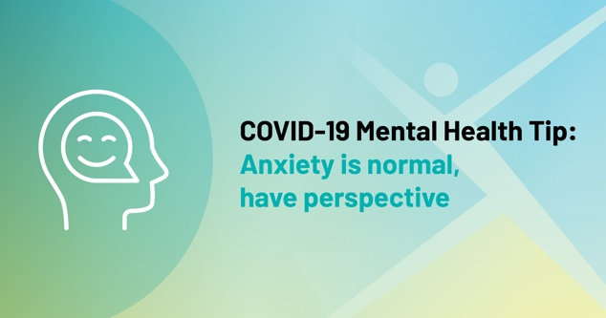 | 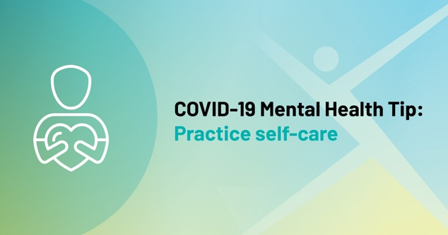
 | 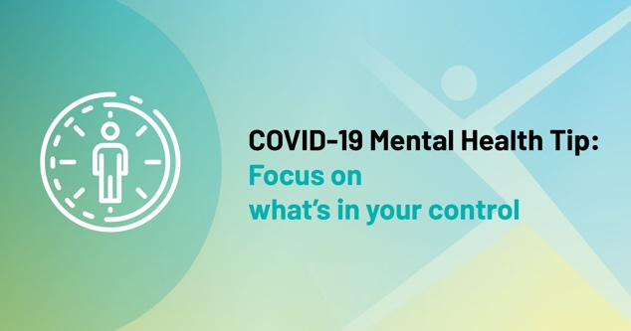

Sharable image for Instagram
